**Installing and configuring CW agent to get memory and disk utilization metrics**

Note: For Amazon Linux machines CW agent is already installed.

For other Linux distributions since the instance resides in private subnet we can use SSM Run command to install the CloudWatch agent.

From the SSM console select the Run command:

Click on the Run command.

Select the Command document : “[AWSEC2-ApplicationInsightsCloudwatchAgentInstallAndConfigure](https://ap-southeast-1.console.aws.amazon.com/systems-manager/documents/AWSEC2-ApplicationInsightsCloudwatchAgentInstallAndConfigure/description?region=ap-southeast-1)”

Scroll down to Target selection and select Choose instance manually and select the instance to installed CW agent.

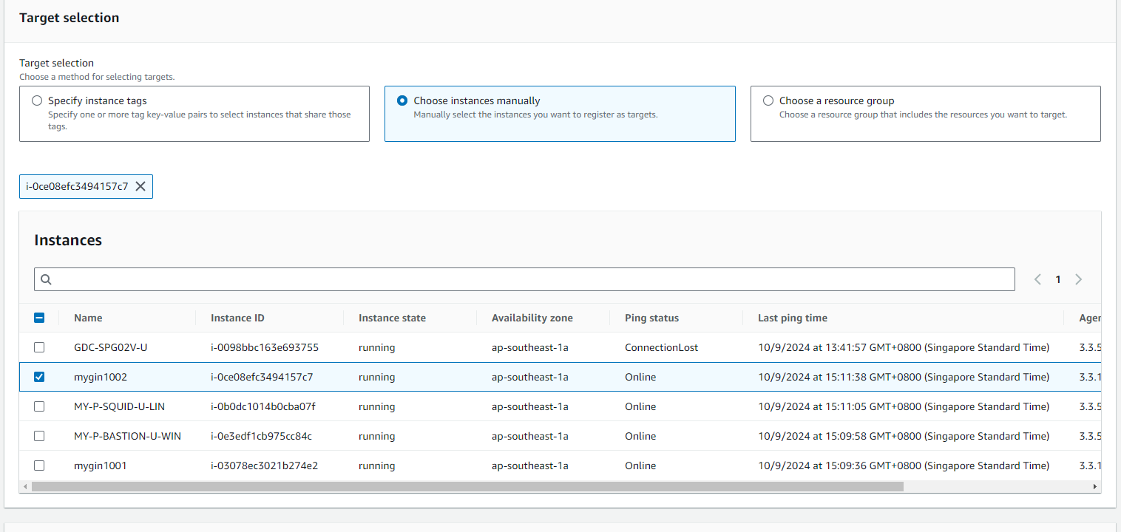

Once selected the instance keep rest of the options as default and click on Run button

**Configuring CW agent using configuration file**

There are two approaches to configure the CW agent :

1: Directly copying the configuration file into instance and configuring it , copy the configuration file for linux or windows from <https://docs.aws.amazon.com/AmazonCloudWatch/latest/monitoring/CloudWatch-Agent-Configuration-File-Details.html> and execute the command :

Sudo /opt/aws/amazon-cloudwatch-agent/bin/amazon-cloudwatch-agent-ctl -a start -m ec2 -c file:/opt/aws/amazon-cloudwatch-agent/etc/amazon-cloudwatch-agent.json

2 : Create a SSM parameter store , copy the CW agent configuration file into SSM parameter store

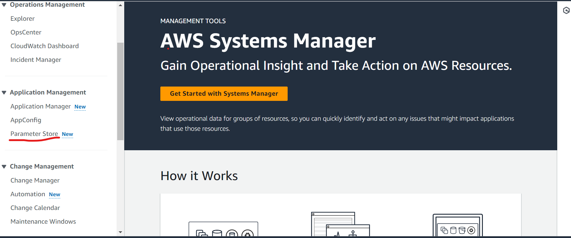

Give the name and select tier as standard and type as string

Paste the CW agent configuration into the value field and click Create parameter.

Once the parameter is created login into the instance in CW agent need to enabled execute the below command

**Sudo /opt/aws/amazon-cloudwatch-agent/bin/amazon-cloudwatch-agent-ctl -a start -m ec2 -c ssm: CloudWatchAgent-linuxConfiguration**

Attach the necessary permissions to the IAM role attached to the instance to push metrics and logs to Cloudwatch . We have added the below permissions to the IAM Role (Instance profile) attached to the instance.

Note: CloudWatchAgentServerPolicy is the permission for CW agent to push metrics to CW.

Once everything is configured we can see the additional metrics collected in Cloudwatch metrics .

CW agent collects the memory and disk utilization metrics that we need to add to the dashboard.